Project Design Phase
Problem – Solution Fit Template

Date | 05 July 2026
Project Name | Cab booking
Maximum Marks | 2 Marks

Problem – Solution Fit Template:
Customer
- Daily commuters
- Students
- Office employees
- Drivers
Template:
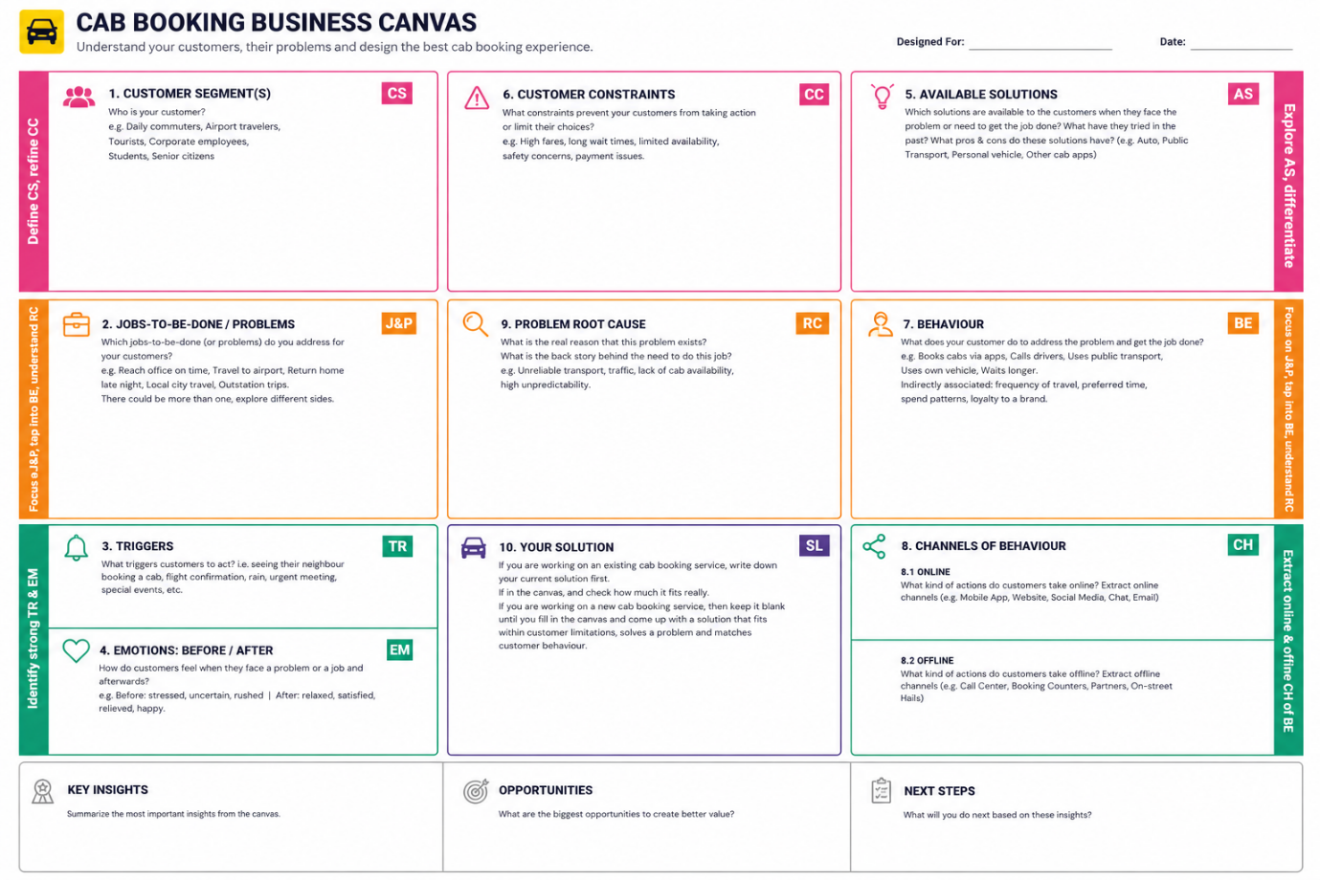

Problems
- Difficulty finding nearby cabs.
- Long waiting time.
- No real-time tracking.
- Limited online payment options.
Solution
Ucab is a MERN Stack web application that allows users to:
- Register and log in
- Book cabs
- Track rides
- Pay online
- View booking history
Key Features
- User & Driver Login
- Cab Booking
- Fare Estimation
- Live Tracking
- Online Payment
- Admin Dashboard
Benefits
- Faster booking
- Secure payments
- Live ride tracking
- Easy ride management
- Better user experience

